Mariner 9 Data Summary

VISUAL IMAGING SYSTEM
Mariner 9 arrived at Mars on 14 November 1971. The first images taken during the spacecraft’s approach showed the planet shrouded in a growing global dust storm. The cameras were programmed to shut down until normal imaging operations were able to continue in December 1971.

Mariner 9 spent 349 days in orbit around Mars returning 7,329 images. These images cover 100 percent of the surface of Mars. Pages 2-10 show a sample of the images returned by Mariner 9 revealing a much more diverse landscape than what had been seen by its predecessors.

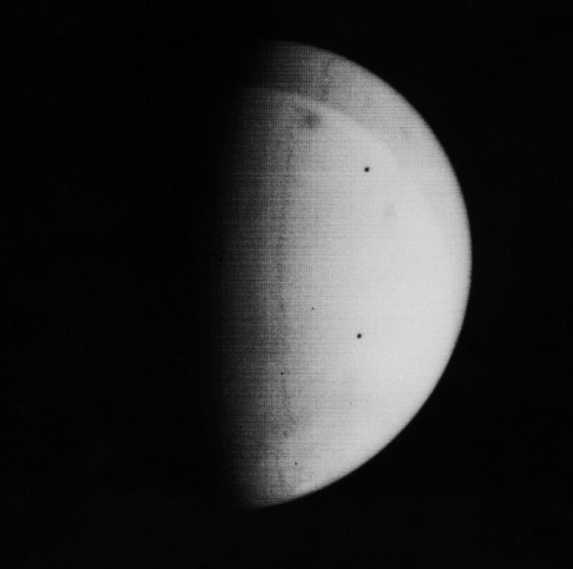

Visual Imaging System wide-angle image taken on approach to Mars.
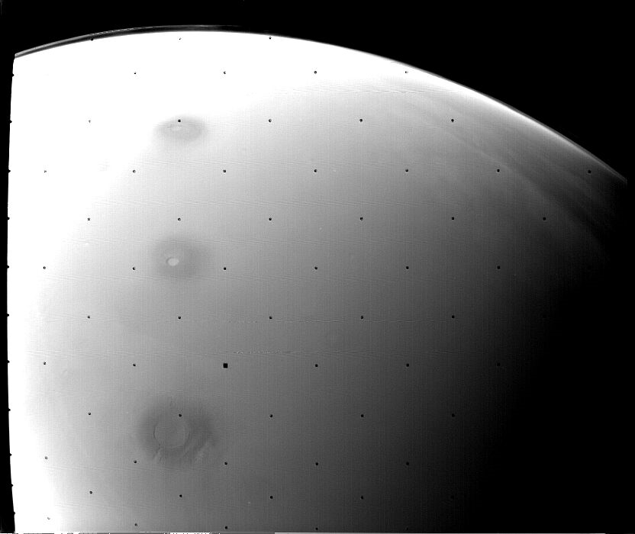

Visual Imaging System wide-angle image taken on approach to Mars.
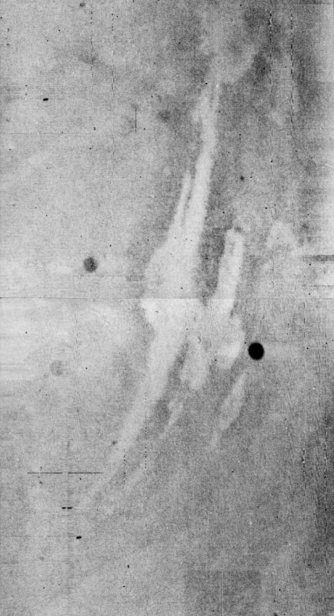

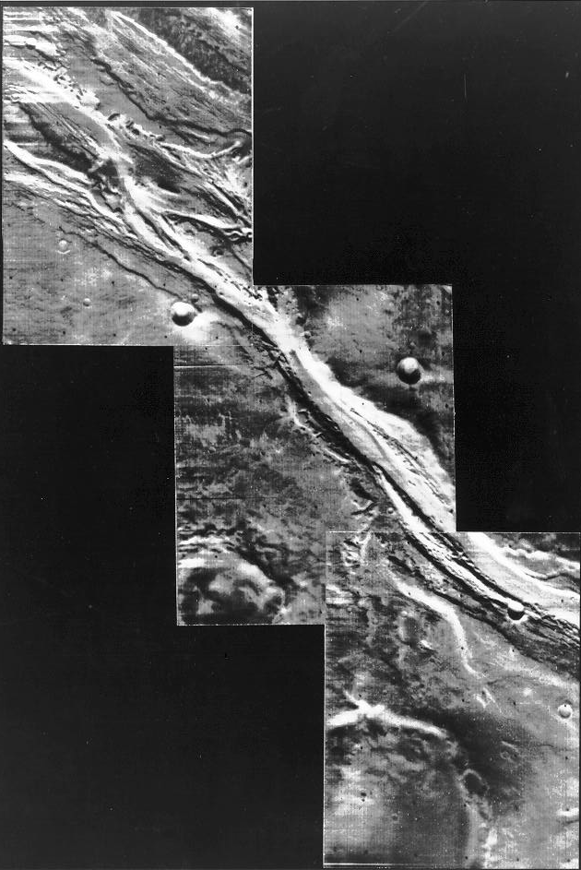
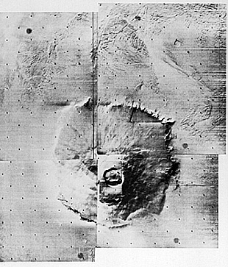

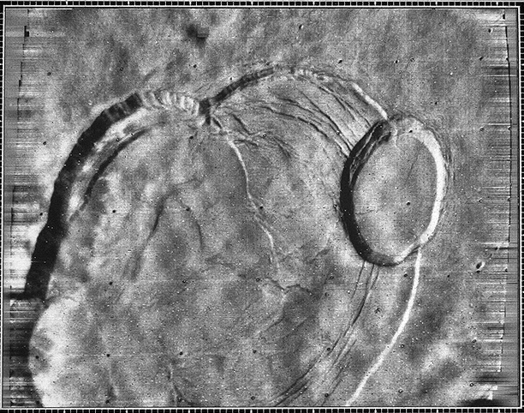
Visual Imaging System narrow-angle camera image centered at 18° N, 133° W.
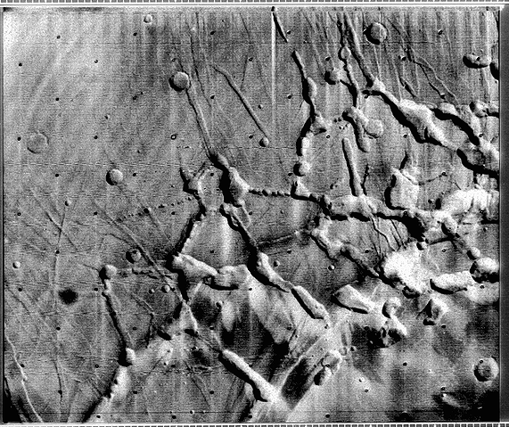
Visual Imaging System narrow-angle camera image centered at 6° S, 105° W.

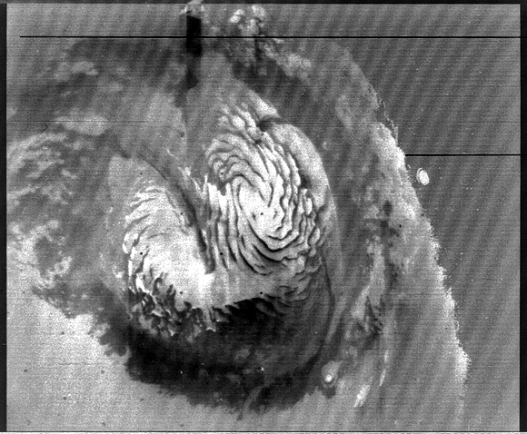
Visual Imaging System wide-angle camera image centered at 89° N, 200° W.
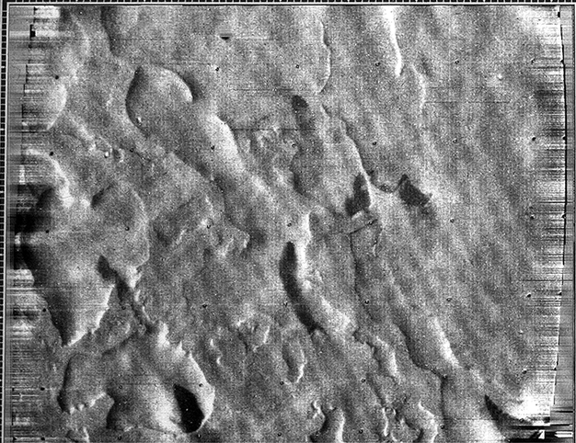
Visual Imaging System narrow-angle camera image centered at 74° S, 7° W.

