Viking Orbiter Data Summary

VISUAL IMAGING SUBSYSTEM
The main functions of the Visual Imaging Subsystems were to aid in the selection of safe, landing sites, to establish the geologic and dynamic environments in which the lander experiments were performed, and to add to our knowledge of the evolution of the Martian surface and the dynamics of its atmosphere. Together, the Viking Orbiters’ Visual Imaging Subsystems mapped 97 percent of the surface of Mars, collecting a total of 52,000 images. Some of these images are presented here on pages 2-8.

The IR Thermal mappers definitively determined the North residual polar cap is composed of water-ice and not frozen carbon dioxide.
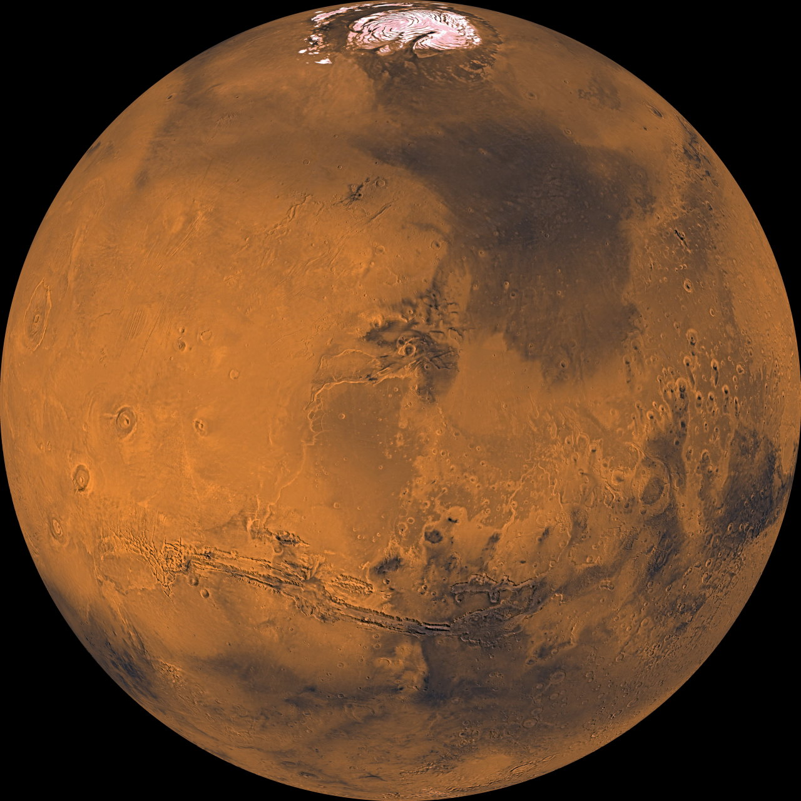
Viking Orbiter global mosaic of Mars.
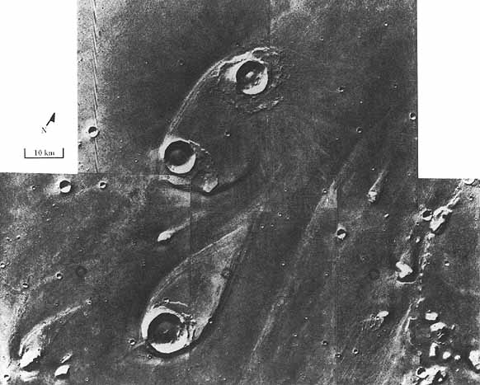
Viking Orbiter image centered at 21°N, 31°W in Chryse Planitia.
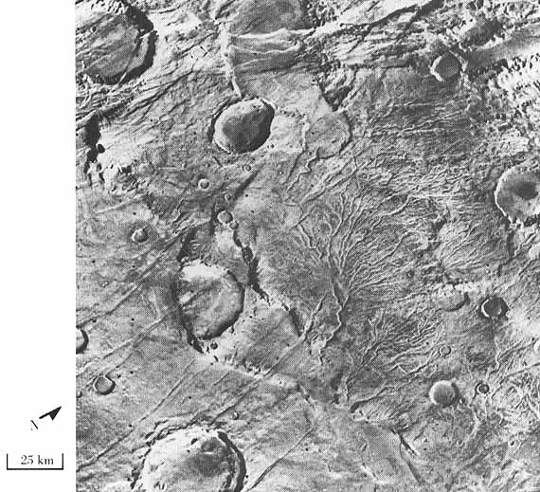
Viking Orbiter image centered at 48°S, 98°W
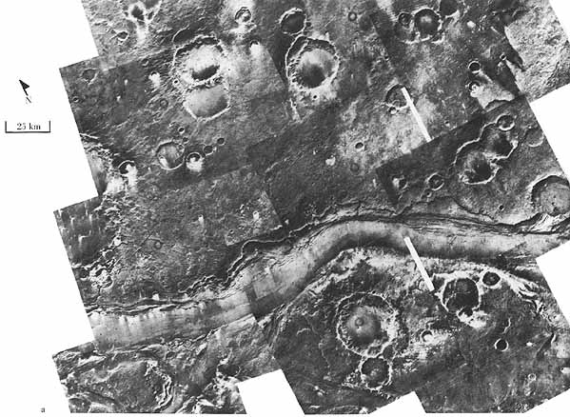
Viking Orbiter image centered at 10° N, 24° W.
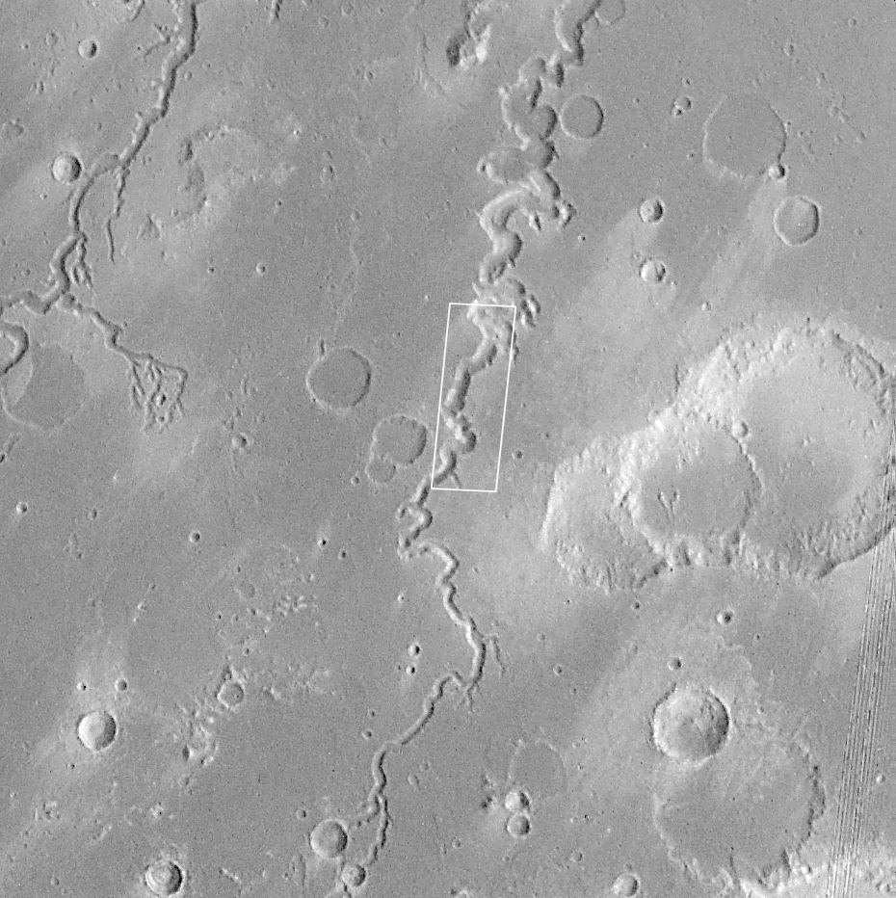
Viking Orbiter image centered at 4.9° N, 49° W.

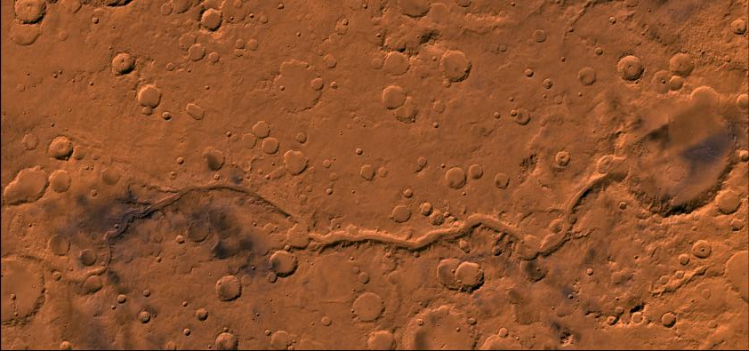
Viking Orbiter image centered at 21° S, 184° W. The large crater on the right is 160km (100 miles) in diameter.

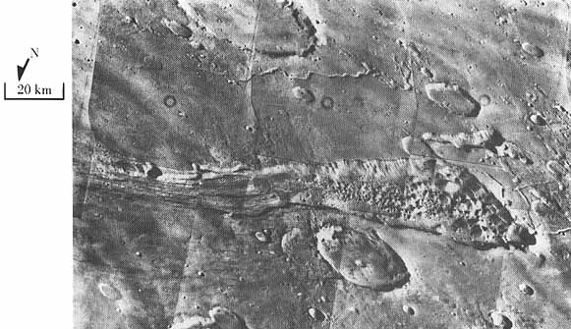
Viking Orbiter image centered at 1°S, 43°W.

Viking Lander Data Summary

BIOLOGY EXPERIMENTS
The Viking landers carried out a series of experiments to determine the composition of the atmosphere and soil, monitor weather conditions at the landing sites, and determine whether the Martian soil contains any form of microscopic life. A short discussion of each experiment follows.

The Gas Exchange Experiment was designed to test whether minute organisms lying dormant in the soil would come to life after addition of water or organic compounds. Both oxygen and carbon dioxide were given off after addition of water, but their release could have been caused by decomposition of the soil.

The Carbon Assimilation Experiment assumed that organisms would thrive in the carbon dioxide-rich atmosphere of Mars and would incorporate or assimilate carbon from the atmosphere in their life processes. Although some carbon compounds were produced during this experiment, they could also have been caused by chemical reactions in the soil.

The Labeled Release Experiment tested whether life processes were present by monitoring the release of radioactive gas introduced to the sample in the form of nutrients. A rapid release of carbon dioxide occurred after the first addition of nutrients, consistent with biological activity. However, the amount of carbon dioxide soon diminished, suggesting that Martian organisms were not responsible.

METEOROLOGY EXPERIMENT
The Viking meteorology experiment measured the atmospheric pressure and temperature, and the wind speed and direction. Continuous weather measurements were made during the first three months of the mission. These records show that the atmospheric pressure was about 7 millibars during the Martian summer, or about 0.007 times the atmospheric pressure on Earth. The mean temperature during the summer was -58 degrees C (-72 degrees F), and wind gusts up to 65 kilometers per hour (40 mph) were measured. Extension of the mission beyond the original three months allowed measurements of seasonal changes at both lander sites. During the first winter at the lander 2 site, temperatures dipped to -113 degrees C (-171 degrees F).

SURFACE COMPOSITION
To determine the composition of the atmosphere, and whether organic molecules exist in the surface samples, a Gas Chromatograph Mass Spectrometer measured the atomic composition of gas samples from heated soil and the atmosphere. No organic molecules were detected at either landing site, but the abundance of the gas argon was found to be less than that expected. This difference suggests that during the early evolution of the planet, the amount of gas released to the atmosphere of Mars was less than that released to the atmosphere of the early Earth.

The composition of heavier elements, those that are common in rocks and soils, was determined by means of an X-ray Fluorescence Spectrometer. Samples of Mars were dropped into the instrument in the Lander body, where they are exposed to high-energy x-rays. Each element then produces its own characteristic x-rays, which are counted and recorded.

Analysis of the surface soil indicates that both landing sites are similar in composition and primarily composed of the elements silicon and iron. The sulfur content is unexpectedly high, and might be caused by water-soluble minerals deposited on the surface. Lander soils could be derived from weathering of an iron-rich igneous rock, such as basalt. Consistent with these analyses, magnetic particles were photographed clinging to the magnets on the sampling arm and on the camera reference chart.

A seismometer aboard Lander 2 indicated that the planet is presently very stable; a similar instrument on Lander 1 failed to operate.

ATMOSPHERIC COMPOSITION

Measurements from the Landers show the atmosphere of Mars to be made of the following gases:

- Carbon dioxide: 95.32%
- Nitrogen: 2.7%
- Argon: 1.6%
- Oxygen: 0.13
- Carbon monoxide: 0.7%
- Water vapor: 0.03%

PANORAMIC CAMERAS
Selected images from both the Viking Landers appear on pages 12-15.

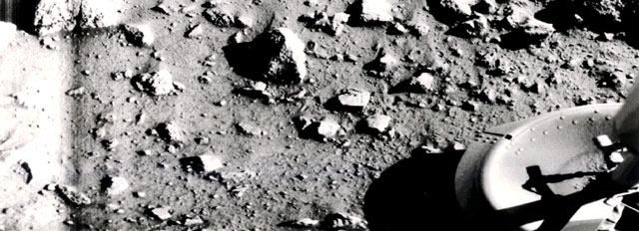
Viking Lander 1 image; first image taken from the surface of Mars at Chryse Planitia.
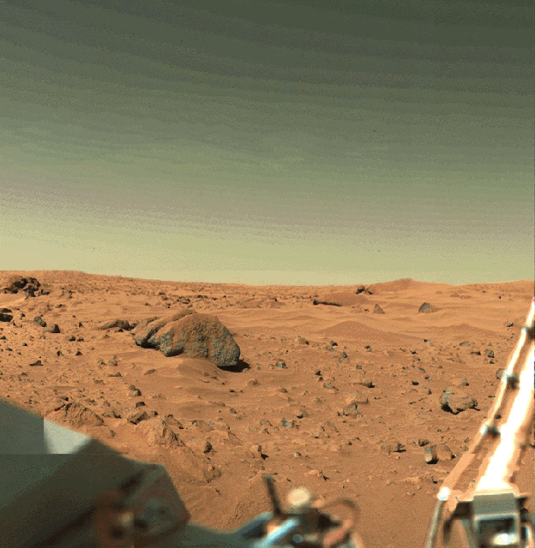
Viking Lander 1 image of Chryse Planitia.
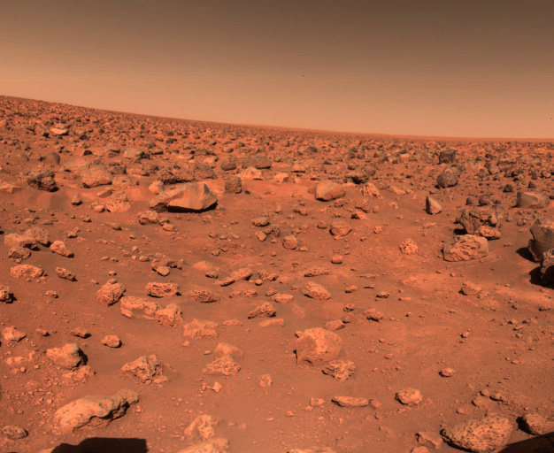
Viking Lander 2 image from Utopia Planitia.
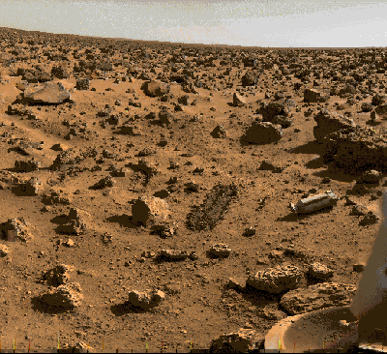
Viking Lander 2 image from Utopia Planitia.

