Mars Odyssey Data Summary

Mission Objectives
- Determine the abundance of hydrogen, most likely in the form of water ice, in the shallow subsurface
- Globally map the elements that make up the surface
- Acquire high-resolution thermal infrared images of surface minerals
- Provide information about the structure of the Martian surface
- Record the radiation environment in low Mars orbit as it relates to radiation-related risk to human exploration

Instruments
- Thermal Emission Imaging System (THEMIS)
- Gamma Ray Spectrometer (GRS)
- Martian Radiation Environment Experiment (MARIE)

The goals of the Gamma Ray Spectrometer (GRS) onboard the Mars Odyssey Orbiter are:
- To quantitatively determine the elemental abundances of the Martian surface
- To map the distribution of water and to determine its near-surface stratigraphy
- To determine the depth of the seasonal polar caps and its variation with time
- To study the nature of cosmic gamma-ray bursts

The Gamma Ray Spectrometer detects gamma rays emitted from the surface of Mars. These gamma rays are released when elements composing the Martian surface interact with cosmic rays from space. GRS has the capability of detecting gamma rays that originate as low as one meter below the surface of Mars.

The data sets on the following pages show the relative abundance of water-ice across Mars (pages 2 & 3) and the percent water weight of water (page 4).

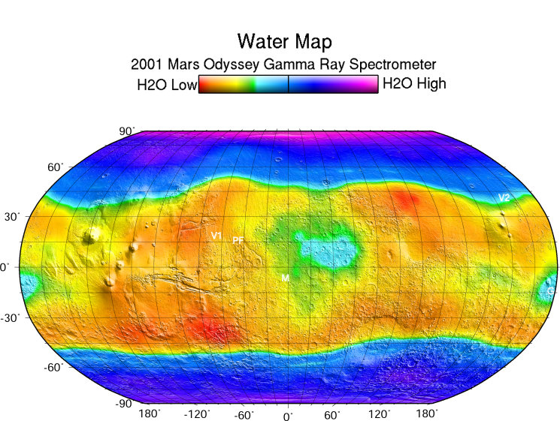

This gamma ray spectrometer map (2004) of the planet Mars is based on gamma rays from the element hydrogen.

Image Credit: NASA/JPL/University of Arizona

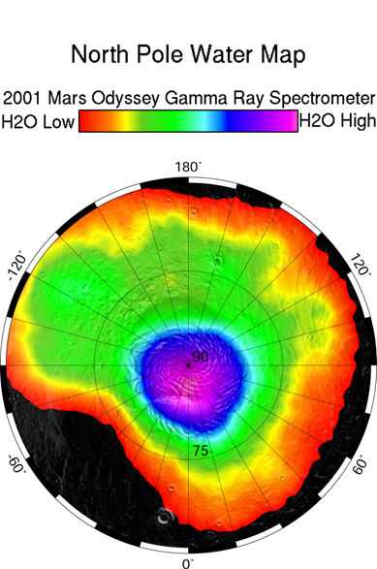
This gamma ray spectrometer map (2004) centered on the north pole of Mars is based on gamma rays from the element hydrogen.

This map (2008) shows concentration estimates of equivalent-weight water found in the equatorial regions of Mars. The map is based upon gamma ray data collected for the element hydrogen.

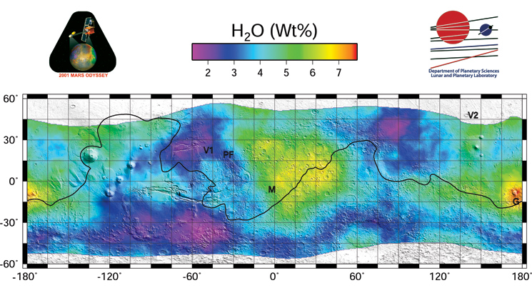
Image Credit: NASA/JPL/University of Arizona

