Mars Phoenix Lander Data

Mission Objectives:
- Study the history of water in the Martian arctic
- Search for evidence of a habitable zone and assess the biological potential of the ice-soil boundary

“The Phoenix has risen!” - Peter Smith, Mars Phoenix Principal Investigator, August 4, 2007

Instruments
- Surface Stereo Imager (SSI)
- Thermal & Evolved Gas Analyzer (TEGA)
- Microscopy, Electrochemistry, and Conductivity Analyzer (MECA)
- Robotic Arm (RA) with rasp tool
- Robotic Arm Camera (RAC)
- Meteorological Station (MET)
- Mars Descent Imager (MARDI)

Phoenix imagery follows.

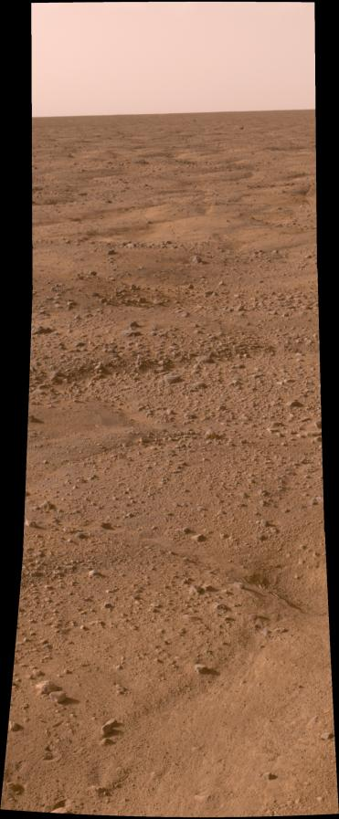

One of the first images of the surface returned by the Phoenix Lander after touchdown on the Martian arctic.

Image Credit: NASA/JPL/University of Arizona/Texas A&M University

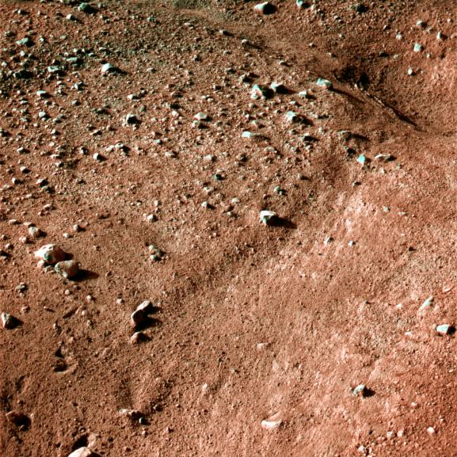
Close-up of the terrain surrounding the Phoenix Lander.

Image Credit: NASA/JPL/University of Arizona/Texas A&M University

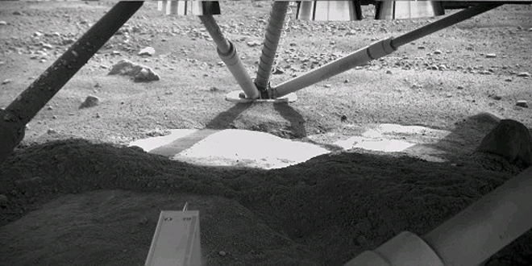
The robotic arm camera takes a peek underneath the Phoenix Lander.

Image Credit: NASA/JPL/University of Arizona

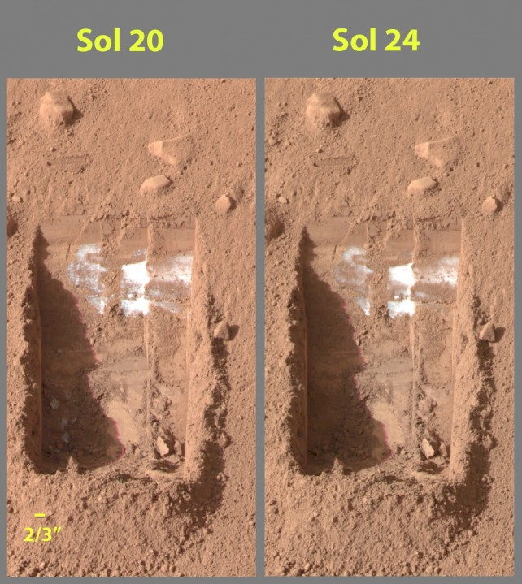

Two images taken two sols apart show changes in white material uncovered by the scoop on the robotic arm.

Image Credit: NASA/JPL/University of Arizona/Texas A&M University

Stereo Surface Imager picture of the robotic arm scoop, MECA instrument, and solar panel.

Image Credit: NASA/JPL/University of Arizona/Texas A&M University
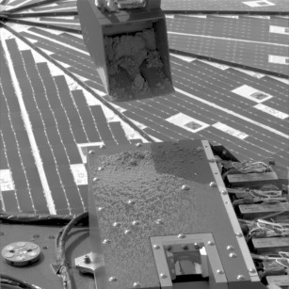

A composite image the Sun’s position in the sky throughout one sol at the Phoenix landing site.

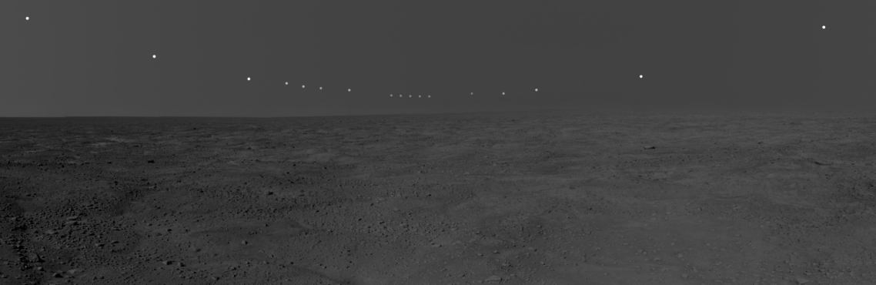
Image Credit: NASA/JPL/University of Arizona/Texas A&M University

