Future in situ balloon exploration of Titan’s atmosphere and surface
(Draft : version 7 – 2 September 2009)

A. Coustenis (LESIA, Paris-Meudon Observatory, 5, place Jules Janssen, 92195 Meudon Cedex, France; Athena.coustenis@obspm.fr; +33145077720) and

J. Lunine (LPL), D. Matson (JPL), K. Reh (JPL), P. Beauchamp (JPL), J.M Charbonnier (CNES, Toulouse), L. Bruzzone (Univ. Trento), M.-T. Capria (IFSI, Rome), A. Coates (MSSL, Univ. College London), C. Hansen (JPL), R. Jaumann (DLR, Berlin), J.P Lebreton (ESA/ESTEC), R. Lopes (JPL), R. Lorenz (APL), I. Mueller-Wodarg (Imp. College, London), F. Raulin (Univ. Paris 12), E. Sittler (NASA/GSFC), J. Soderblom (LPL), F. Sohl (DLR, Berlin), C. Sotin (JPL), T. Tokano (Univ. Koln), T. Spilker (JPL), N. Strange (JPL), E. Turtle (APL), H. Waite (SWRI), L. Gurvits (JIVE), C. Nixon (NASA/GSFC), T. Livengood (NASA/GSFCF), J. Blamont (CNES, Paris), R. Achterberg (NASA/GSFC), M. Allen (JPL), C. Anderson (NASA/GSFC), D. Atkinson (Univ. Idaho), T. Balint (JPL), G. Bampasidis (Univ. Athens), D. Banfield (Cornell), A. Bar-Nun (Tel-Aviv Univ., Israel), J. Barnes (Univ. Idaho), R. Beebe (New Mexico State Univ.), E. Bierhaus (Lockheed Martin), G. Bjoraker (NASA/GSFC), D. Burr (Univ. Tennessee), C. Conley (NASA/AMES), F. Crary (SWRI), J. Cui (Imp. College, London), J. Elliott (JPL), M. Flasar (NASA/GSFC), A. Friedson (JPL), M. Galand (Imp. College, London), D. Gautier (Paris-Meudon Observatory), M. Gurwell (CFA, Harvard), J. Head (Raytheon), M. Hirtzig (Paris Obs.), T. Hurford (NASA/GSFC), T. Johnson (JPL), K. Klaus (Boeing), W. Kurth (Univ. Iowa), J. Martin-Torres (Caltech), K. Mitchell (JPL), X. Moussas (Univ. Athens), M. Munk (NASA/LRS), C. Neish (APL), L. Norman (UCL), B. Noyelles (Univ. Namur), G. Orton (JPL), T. Owen (IfA, Hawaii), D. Pascu (US Naval Obs.), E. Pencil (NASA/GRC), S. Rafkin (SWRI), T. Ray (JPL), F. Rocard (CNES, Paris), H. Roe (Lowell Obs.), A. Solomonidou (Univ. Athens), L. Spilker (JPL), R. West (JPL), D. Williams (ASU, SESE), E. Wilson (JPL and Univ. Michigan), M. Wright (NASA/AMES), V. Zivkovic (Univ. North Dakota).

For the full list of the current 79 authors with complete affiliations and e-mails see:
http://www.lesia.obspm.fr/cosmicvision/tssm/tssm-public/?cat=25
(The OPAG Titan Working Group Web site, Documents Section, Password: TWG_2009; see also: http://www.lpi.usra.edu/decadal/opag/)
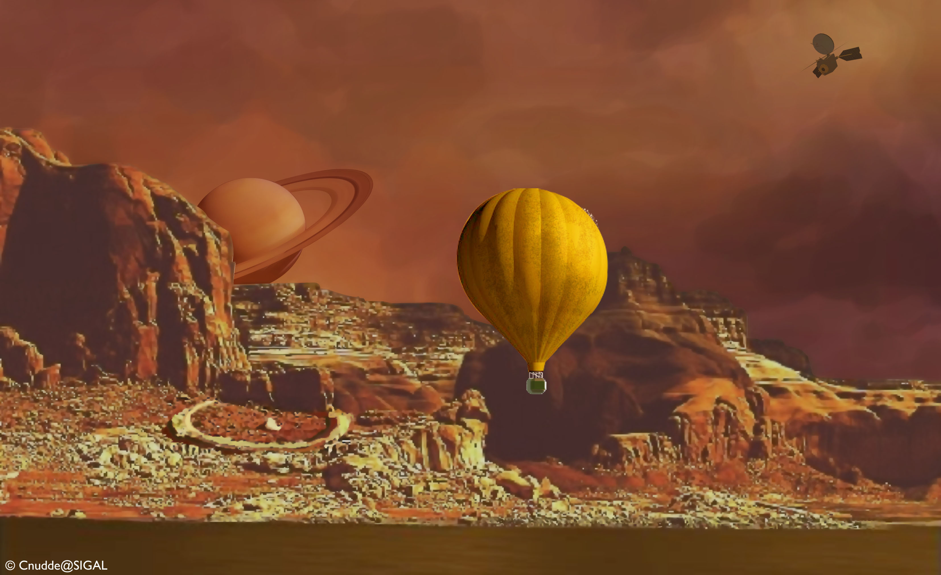
Abstract: Many of the questions remaining to be addressed after the Cassini-Huygens mission require both remote and in situ elements to achieve the desired science return. Our understanding of the lower atmosphere, surface and interior (subsurface ocean) of Titan will benefit greatly from detailed investigations at a variety of locations, a demanding requirement anywhere else, but one that is uniquely possible at Titan using a hot-air balloon (montgolfière).

- Scientific motivation for a montgolfière on Titan
A wide range of high priority scientific investigations at Titan remains to be addressed after the Cassini-Huygens mission (cf. the 2008 joint NASA-ESA Titan Saturn System Mission study final report). Recent findings from Cassini Huygens answered some questions but also raised many more. Cassini will not be able to comprehensively address many of these questions because of inherent limitations in the instrument suite and because both remote and in situ elements are required to achieve much of the desired science return. Whereas a spacecraft in orbit around Titan could allow for a thorough investigation of Titan’s upper atmosphere, there are questions that can only be answered by extending the measurements into Titan’s lower atmosphere and down to the surface. Key steps toward the synthesis of prebiotic molecules that may have been present on the early Earth as precursors to life might be occurring high in the atmosphere; the products then descending towards the surface where they might replicate. In situ chemical analysis of gases, liquids, and solids, both in the atmosphere and on the surface, would enable the identification of chemical species that are present and how far such putative reactions have advanced. The rich inventory of complex organic molecules that are known or suspected to be present in the lower atmosphere and at the surface gives Titan a strong astrobiological potential (Pilcher, C., for the NAI Executive Council, “Titan is in the List of Highest Priority Astrobiological Targets in the Solar System”, 22 September 2008).
Our understanding of the forces that shape Titan’s diverse landscape (dunes, cryovolcanoes, rivers, etc) and interior (subsurface ocean) will benefit greatly from detailed investigations relying on very high-spatial-resolution remote sensing at a variety of locations, a demanding requirement anywhere else, but one that is uniquely possible at Titan using a hot-air balloon (montgolfière). Indeed, Titan’s thick cold atmosphere and low gravity make the deployment of in situ elements using parachutes (as demonstrated by the Cassini-Huygens probe) and balloons vastly easier than for any other solar system body. A montgolfière floating across the Titan landscape for long periods of time (Earth months or even years), with an adapted payload, would offer the mobility required to explore the diversity of Titan in a way that cannot be achieved with any other platform.
In situ elements would also enable powerful techniques such as subsurface sounding and potentially seismic measurements, to examine and better understand Titan’s crustal structure.
Indeed, for the following reasons, Titan is the best place in the solar system for scientific ballooning:
- Its atmosphere is cold and dense: 5 kg/m³ at the surface compared to 1 kg/m³ on Earth. Therefore the effect of differential molecular mass between the buoyant gas and the ambient air is maximized.
- The low value of solar radiation (10⁻² of radiation at Earth) creates, in all practicality, no diurnal variation of the external energy source and opens the possibility of long duration flights – less stress on balloon materials and cyclic impact on buoyancy.
- Because of the scale height of Titan’s atmosphere, inflation during descent occurs over a long period; for example, it can be initiated at a vertical velocity of 5 m/s¹ around 30 km of altitude (20 mbar pressure) and completed over a number of hours (compared to 30 m/s¹ initial velocity).
A montgolfière balloon has been identified in years of previous science driven mission studies as a necessary element in a comprehensive Titan exploration program. The most recent studies include the 2003 Vision Missions study, 2006 Titan Pre-biotic Explorer Study (TiPEx), 2007 Titan Explorer Flagship study, and the 2008 joint NASA/ESA Titan Saturn System Mission (TSSM) study. As a result of the 2008 TSSM study, the science panels and review boards confirmed that an orbiter and in situ elements are needed for a credible flagship mission to Titan.
While other elements identified in Titan mission architectures (notably landers/surface elements) appear to have significant flight heritage, a balloon has not been flown at Titan before and will require further development. The 2008 TSSM NASA and ESA technical review boards confirmed the feasibility of implementing a montgolfière balloon at Titan and identified the following risks that should be addressed to demonstrate flight readiness,
- Balloon deployment and inflation upon arrival at Titan
- Balloon packaging inside the aeroshell with RPS thermal management
- Interface complexity between balloon, RPS, and aeroshell
- Late integration of the NASA provided MMRT
To ensure readiness for launch of a flagship mission to Titan, JPL and CNES are entering into a joint risk reduction effort directed at maturing the flight readiness of the Titan montgolfiere. This activity would be co-funded by NASA and CNES over a multi-year period with the objective of achieving TRL 5–6 by 2015. The effort would leverage the complementary planetary flight system experience and balloon design and operational capabilities of JPL and CNES.
While a wide range of balloon architectures are viable at Titan (Lorenz, 2008), the reasons outlined here, as well as the science objective to achieve at least one circumnavigation of Titan (> 6 months lifetime), favor the choice of a montgolfière. It should be noted that since the montgolfière uses Titan’s atmosphere and the thermal heat from its radioisotope power system to maintain buoyancy, it does not include the complexity, mass, and limited life of a lighter-than-air gas supply (e.g., hydrogen) and inflation system.
Ever since its discovery by the Montgolfier brothers, the montgolfière balloon has attracted significant attention in Earth’s exploration and more recently for planetary missions. Balloons offer the only possibility today of conducting a long-duration voyage in the atmospheres of Venus, Mars, and Titan. To date, only in Venus’ atmosphere have balloons been deployed. A montgolfière is an open balloon with an aperture equal to approximately one tenth of the maximum diameter of the balloon envelope. During descent and inflation, the balloon fills with ambient Titan gas which is heated by the radioisotope power system heat to achieve neutral buoyancy. There is a large body of US, European, and Russian experience in flying Earth-based montgolfières, as well as limited experience with planetary balloons (Venus). Since 1979, CNES has flown on average 2 to 5 long-duration infrared-heated montgolfières per year. Also, JPL has conducted high altitude drop tests on Earth that have demonstrated the deployment and inflation of montgolfière balloons similar to what would be flown on Titan.
A montgolfière as envisioned in previous mission studies, is capable of circumnavigating Titan every 3 to 6 months. Carried by 1-3 m/s winds, a Titan montgolfière could explore the Titan environment with a host of highly capable instruments, including high-resolution cameras, chemical analyzers and subsurface-probing radar. There are no obvious life-limiting factors, and so its flight could continue for many months, perhaps even years and could provide global coverage from a nominal altitude of about 10 km (Fig. 1). Furthermore, the capability of performing surface sampling from the balloon has been investigated and development of this capability would further increase the science value of such a mobile platform.
Figure 1 Titan montgolfière concept.
Credit: C. Waste.
The combination of orbiting and in situ elements would provide a comprehensive and, for Titan (indeed, for the outer solar system!), unprecedented opportunity for synergistic investigations. The balloon platform alone, with a carefully selected instrumentation suite, is a powerful pathway to understanding this profoundly complex body. The montgolfière is Titan’s “Rover”, albeit with the advantage of an extended range.

2) Science return with the in situ balloon
Titan is a very complex world (Fig. 2). It is the only one we know of today, beyond our own planet, not only to possess a thick nitrogen-based atmosphere, but also a geologically complex active surface with lakes and organic deposits and quite likely a sub-surface ocean. The physical processes within this world beg for further investigation in order to better understand these processes, not only on Titan, but also on Earth. If we are to focus on the Earth and its climate (cf. Nixon et al. Decadal White Paper on “Titan’s greenhouse effect and climate”), as well as on its organic chemistry, we need in the future to concentrate on Titan, which sustains an active hydrologic cycle with surface liquids, meteorology, and climate change as established by Cassini Huygens.

2.1) Scientific objectives for a montgolfière on Titan
A montgolfière on Titan would open the possibility to address the following science objectives:
- Perform chemical analyses in the atmosphere and the surface (options for in situ sampling of the surface, such as via a tether or via end-of-mission slow descent onto the surface, can be explored), the latter to determine the kinds of chemical species that accumulate on the surface (Fig. 2), to describe how far complex reactions have advanced, and define the rich inventory of complex organic molecules that are known or suspected to be present at the surface. New astrobiological insights will be inevitable from the possible combination of orbiter, montgolfière, and lander (or surface in situ sampling via a montgolfière) investigations.
- Analyze the regional geology and composition of the surface, in particular any liquid or dune material and in context, the ice content in the surrounding areas by hyper-spectral imaging.
- Study the forces that shape Titan’s diverse landscape. This objective benefits from detailed investigation at a range of locations; the atmospheric conditions present at Titan make this relatively straightforward with a montgolfière equipped with high-resolution cameras and subsurface-probing radar.

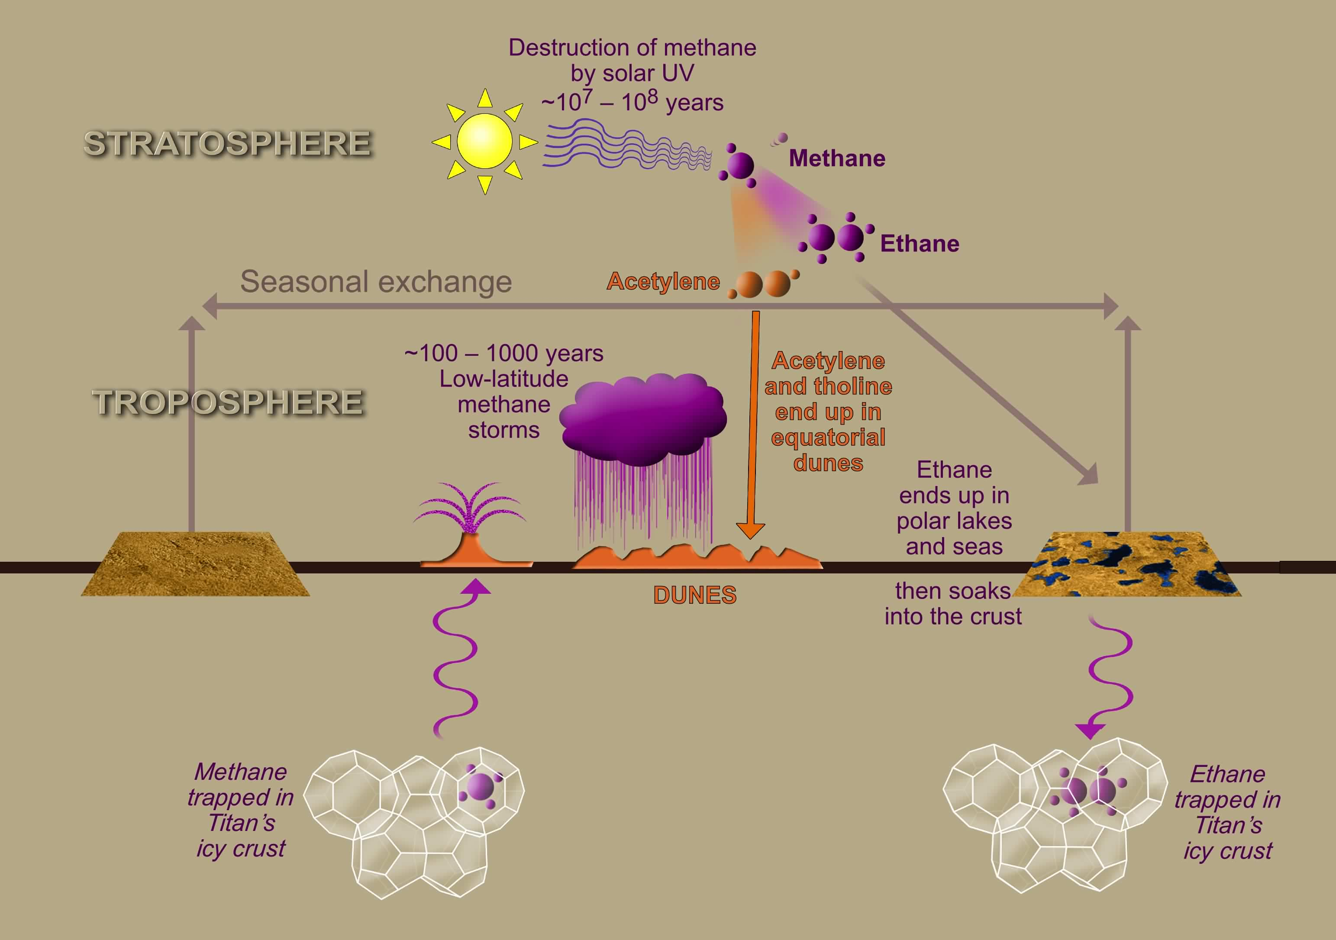
Figure 2. Schematic of Titan’s methane cycle and of the atmosphere-surface interactions that could be investigated by a montgolfière (re-drafted from Lunine and Atreya, 2008).

Thus, a long-lived in situ balloon, could contribute to or achieve the following investigations:
- Determine the composition and transport of volatiles and condensates in the atmosphere and at the surface, including hydrocarbons and nitriles, on both regional and global scales, in order to understand the hydrocarbon cycle. Determine the climatological and meteorological variations of temperature, clouds, and winds.
- Characterize and assess the relative importance, both past and present, of Titan’s geologic, marine, and geomorphologic processes (e.g., cryovolcanic, aeolian, tectonic, fluvial, hydraulic, impact, and erosion).
- Determine the chemical pathways leading to formation of complex organics in Titan's troposphere and their modification and deposition on the surface with particular emphasis on ascertaining the extent of organic chemical that has evolved on Titan.
- Determine geochemical constraints on bulk composition, the delivery of nitrogen and methane, and exchange of surface materials with the interior.
- Determine chemical modification of organics on surface (e.g., hydrolysis via impact melt).

2.2) Titan investigation “Firsts” achievable with a montgolfière balloon
Depending on where the balloon might be placed (equator, north pole, etc.), a significant part of the lower atmosphere of Titan, still largely unknown today, will be thoroughly explored around the altitudes of the balloon’s trajectory. Important information will be gained on the lower atmosphere and its interactions with the surface. Similarly, detailed images of thousands of kilometers of Titan’s varied terrain, with image quality equal to or better than that of the Huygens probe during its descent, will reveal the extent of fluvial erosion on Titan, well matched to the scales mapped globally by the orbiter. This mobile capability will enable several significant scientific “firsts”:
- First analysis of the detailed sedimentary record of organic deposits and crustal ice geology on Titan, including the search for porous environments (“caverns measureless to man”) hinted at by Cassini on Xanadu.
- Direct test through in situ meteorological measurements of whether the large lakes and seas control the global methane humidity, which is key to the methane cycle.
- First in situ sampling of the winter polar environment on Titan, a region expected to be vastly different from the equatorial atmosphere explored by Huygens.
- Compositional mapping of the surface at scales sufficient to identify materials deposited by fluvial, aeolian, tectonic, impact, and/or cryovolcanic processes.
- First search for a permanent magnetic field unimpeded by Titan's ionosphere.
- First direct search for the subsurface water ocean suggested by Cassini.
- First direct, prolonged exploration of Titan’s complex lower-atmosphere winds.
- Exploration of the complex organic chemistry in the lower atmosphere and surface liquid reservoirs discovered at high latitudes by Cassini.

3) A possible scenario for the delivery and deployment of the montgolfière
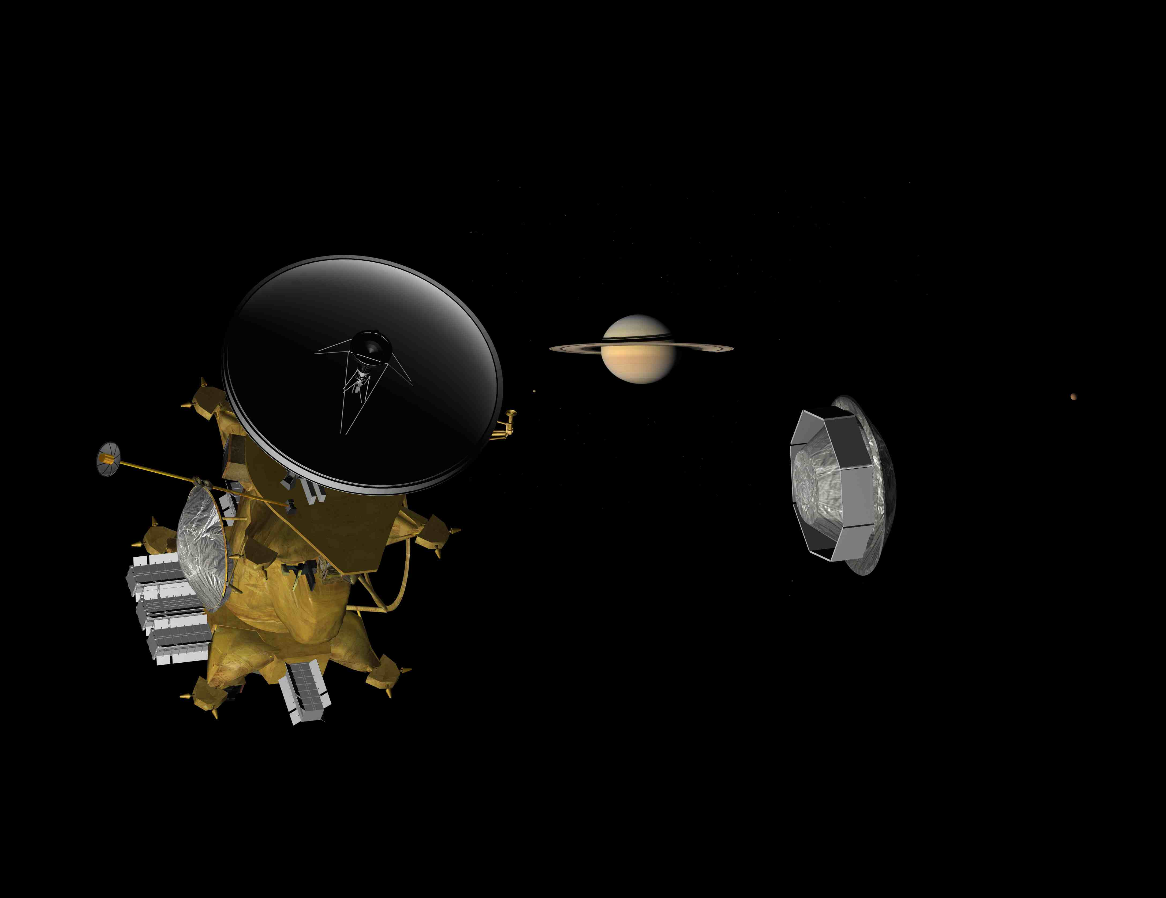
The 2008 TSSM study developed a possible scenario for the delivery and deployment of a hot-air balloon in Titan’s atmosphere and a scheme for conducting science operations. In brief, the montgolfière would be released on approach to the first Titan flyby for a ballistic entry into Titan (Fig. 3). At its deployment latitude of ~20°N (where the most desirable zonal winds are expected), analysis based on Cassini-Huygens results indicates that the montgolfière should circumnavigate Titan at least once over a 6-month period.
Figure 3 The release of the montgolfière from the TSSM orbiter (TSSM report, 2008).
The 2.6-m diameter entry vehicle and its encapsulated montogolfière would have a mass of ~600 kg. The balloon itself could be ~10.5 m in diameter with its entrained gas heated by a multi mission radioisotope thermoelectric generator power system (MMRTG). The gondola, as defined by the TSSM studies, would weigh 144 kg, including 22 kg of science instruments. The electrical power would be provided through the MMRTG (~100 W).
With these parameters, and a wind speed of about 1 m/s, a nominal lifetime of 6 months is expected to meet the science requirement of achieving at least one circumnavigation of Titan. The montgolfière entry, descent and inflation scenario is shown in Fig. 4.

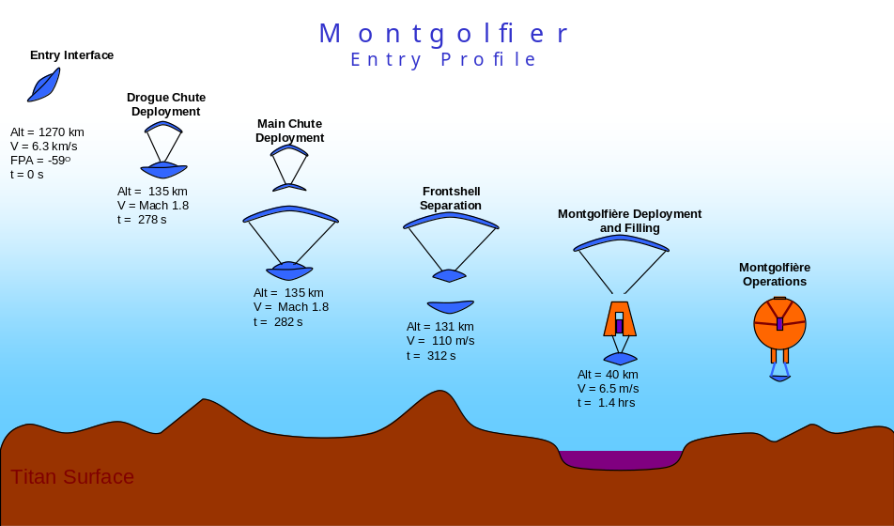
Figure 4: Montgolfière entry, descent and inflation (EDI) scenario (ESA TSSM assessment report, 2008).

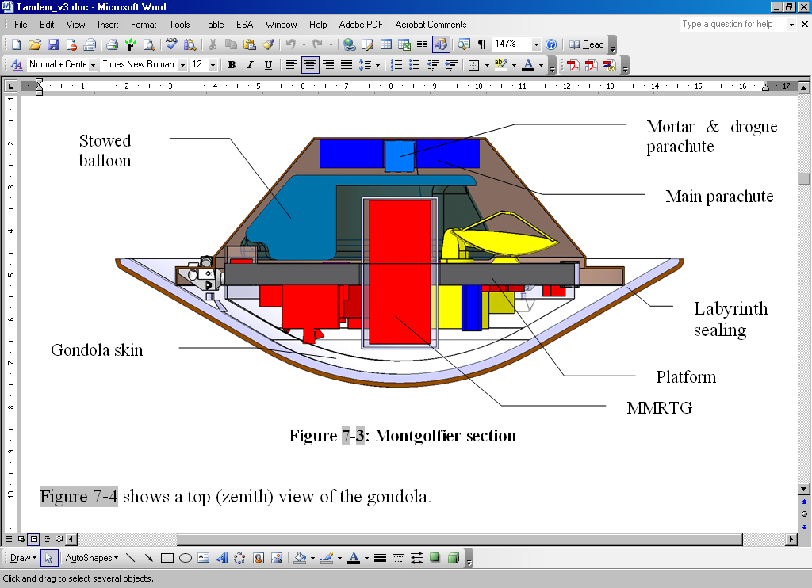
The balloon would be deployed at ~40 km in altitude. The airflow from the descent would fill the balloon envelope while it is simultaneously being heated beyond the local ambient air by the MMRTG. After ~13 hours, a stable altitude will be reached.
Figure 5 : montgolfière configuration (ESA TSSM assessment report).
The montgolfière configuration is shown in Fig. 5.
Communications will be achieved through an orbiter-to-balloon relay. The orbiter tracks the montgolfière and closes the communications link during each flyby and throughout its orbit in the Saturnian system. A beacon signal is used to support establishment of the relay link. The direction to the Earth will be determined through the aid of sun sensors.

4) Key measurements aboard the montgolfière
Key instruments would be placed aboard the gondola of the balloon to secure and optimize the science return. Some of them are described hereafter including their related measurements.

4.1) Chemical analysis of the atmosphere with the montgolfière:
This mission would allow us to determine the methane and ethane mole fractions; to measure the noble gas concentration to 10s of ppb to detect and characterize molecules at concentrations above ppm levels, and to determine the concentration of aerosol particles as well as the bulk composition of individual particles.

4.2) Hyperspectral imaging with the montgolfière
Near-infrared spectroscopy of the surface from the montgolfière will provide high-resolution views of the surface composition from reflectance spectroscopy across the organic (or organic-coated) dunes, outwash plains and channels, impact craters and cryovolcanic features, and the enigmatic circular features of the low latitudes at regional and local scale with a spectral sampling of 10 nm.
A unique feature of the montgolfière will be its ability to circumnavigate the globe at low altitudes (10 km and lower) enabling very-high-resolution imaging of a broad sweep of terrains. The montgolfière camera will perform stereo panoramic and high-resolution geomorphological studies at resolutions of better than 10 m per pixel, and select areas at 1 m per pixel with a narrow angle camera (Fig. 6). Several thousand images at least will be returned to the orbiter for relay to the Earth, over hundreds of thousands of square kilometers, a non-negligible fraction of Titan’s surface area. Since resolutions among the three cameras (the orbiter, and the montgolfière wide- and narrow-angle cameras) vary by an order of magnitude or less, the suite of cameras are almost ideally matched to provide scene context from the orbiter camera to the montgolfière wide-angle camera, and from the montgolfière wide- to the narrow-angle camera.
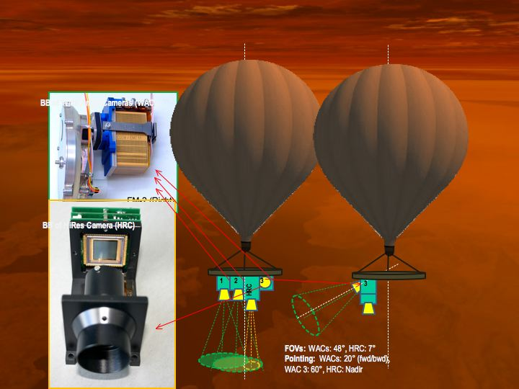
The list of applications of such images includes fluvial erosion, transport, and sedimentation. From Cassini Orbiter Titan Radar images, broad valleys are seen at 300–500 m resolution (Jaumann et al., 2008, 2009), but there is no information as to the density of smaller-scale fluvial features. Is there higher order branching of the broad valleys into dense networks of fluvial features? The TSSM orbiter with the montgolfière imaging systems will trace fluvial drainage systems from the largest channels down to Huygens scale features, providing the first possibility to determine processes of origin and calculate how much methane has flowed across various parts of Titan’s surface. These data will also afford a detailed crustal stratigraphic profiling of a number of types of terrains that have been identified on Titan, from possible cryovolcanic flows, to plains, to mountains, thus enhancing our understanding of the geologic evolution of Titan.
Figure 6: Imaging system on a Titan balloon. R. Jaumann.

4.3) Atmospheric structure and metorology instrument (ASI/MET)
In situ measurements are essential for the investigation of the atmospheric structure, dynamics and meteorology. The estimation of the temperature lapse rate can be used to identify the presence of condensation and eventually clouds, and to distinguish between saturated and unsaturated and stable and conditionally stable regions. The variations in the density, pressure and temperature profiles provide information on the atmospheric stability and stratification and on the presence of winds, thermal tides, waves and turbulence in the atmosphere.
ASI/MET will monitor environmental physical properties (density and mean molecular weight) of the atmosphere from the aerobot. ASI/MET data will also contribute to the analysis of the atmospheric composition. It will provide unique direct measurements of pressure and temperature through sensors having access to the atmospheric flow.

4.4) Radar sounding
This instrument is useful for reconstructing the geological history of Titan, characterizing and assessing the present day sedimentary environments and geomorphological features and identifying the stratigraphic relationships of ancient sedimentary units. More generally, it will allow us to detect sub-surface profiles and possible interfaces due to the presence of liquid or other structures (e.g., of tectonic or cryovolcanic origin).

4.5) Magnetometry
The magnetometer will measure the magnetic field in the spacecraft vicinity in the bandwidth DC to 64Hz, depending on science requirements and available telemetry. Also gradiometry measurements will be performed. Magnetometry aboard the montgolfière and lake lander allow for sensitive field measurements beneath Titan’s screening ionosphere. Crustal magnetism will also be searched for.

4.6) Radio science:
The radio science suite of the Titan montgolfière could address the following scientific areas:
  - Diagnostics of the wind profiles and dynamics by means of Doppler and Very Long Base Interferometry (VLBI) tracking;
  - Diagnostics of the radio propagation media (Titan atmosphere and ionosphere, interplanetary medium) by means of radio signal monitoring;
  - Radio navigation support of in situ experiments and measurements (such as attributing specific topo coordinates to various in situ measurements);
  - Diagnostics of the dynamics of motion of the gondola.
The set of on-board devices able to address the above tasks will be a straightforward and affordable addition to the service radio system. In combination with the Earth-based network of radio telescopes and deep-space communication stations, the montgolfière’s radio system will enable the Planetary Radio Interferometry and Doppler Experiment with the Titan montgolfière (PRIDE-TM). While specific characteristics of PRIDE-TM should be assessed in conjunction with the overall architecture and design parameters of the montgolfière system, it is safe to assume that the lateral positional accuracy can reach values better than 100 m over 10 s integration (X-band operations). Further enhancement of the radio science experiments could be achieved by combining PRIDE-TM with multi-spacecraft radio measurements involving the balloon, orbiter, and Earth-based antennas. With altimetry capabilities we shall be able to map out topography (i.e., reconnaissance phase) for safe navigation down to the surface.

4.7) Direct-to-Earth (DtE) data transmission
The nominal TSSM mission scenario assumes transmission of the science and housekeeping data from the Titan in situ elements via relay by the orbiter. Indeed, the amount of data produced by the Titan montgolfière (e.g. images) and/or surface elements will require a high-capacity radio relay system. However, as an efficient backup for critical mission operations and experiments, a low data-rate link can be achieved with the nominal transmission from the montgolfière and received by large Earth-based radio telescopes. The most attractive option of DtE would involve the Square Kilometer Array (SKA) as the Earth-based facility operating at S band (2.3 GHz) frequencies. This facility is expected to be fully operational in 2020. As shown by preliminary assessment estimates (Fridman et al. 2008), SKA will be able to receive data streams from the TSSM mission through their low-gain transmission at the rate of 30—100 bps.

5) Summary and recommendations
Previous studies have identified the montgolfière balloon as a key element in a comprehensive Titan exploration strategy with very high science value. The most recent 2008 joint NASA/ESA Titan Saturn System Mission (TSSM) study provided a compelling concept for implementation of a montgolfière at Titan. While orbiter and lander elements appear to have significant flight heritage, a balloon has not yet been flown at Titan and will require a focused study.
Based upon the high priority of Titan science, results from many years of mission studies, and current state of technology readiness, the co-authors of this paper recommend the following be pursued:
- Conduct focused studies of Titan balloon mission options, leveraging from previous work, to ceoncentrate on selection of architecture(s) that best enable the achievement of highest priority decadal science (the sweet spot).
- Initiate substantial sustained investment in risk reduction efforts needed to mature the Titan balloon concept for flight readiness.
Early and sustained investment at reasonable levels would result in the demonstration of technical readiness acceptable for launch of a Titan balloon mission in the coming 10—15 years.

References
- http://www.lesia.obspm.fr/cosmicvision/tssm/tssm-public/;
- http://sci.esa.int/science-e/www/area/index.cfm?fareaid=106;
- http://opfm.jpl.nasa.gov/titansaturnsystemmissiontssm/
- Lunine, J.I. and Atreya, S.K. 2008. The methane cycle on Titan. Nature Geoscience 1, 160-164.
- TSSM Final Report on the NASA Contribution to a Joint Mission with ESA, 3 November 2008, JPL D-48148, NASA Task Order NMO710851
- TSSM in situ elements, ESA assessment study report, ESA-SRE(2008)4
- TSSM NASA/ESA Joint Summary Report, 15 November 2008, ESA-SRE(2008)3, JPL D-48442, NASA Task Order NMO710851
- Leary, J., Jones, C., Lorenz, R., Strain, R. D., and Waite, J. H., 2007, Titan Explorer NASA Flagship Mission Study, JHU Applied Physics Laboratory, August 2007.
- Fridman, P. A., Gurvits, L.I., and Pogrebenko, S.V., 2008, http://www.skatelescope.org/pages/page_astronom.htm
- Jaumann, R., et al., 2008. Icarus, 197, 526–538, doi:10.1016/j.icarus.2008.06.002.
- Jaumann, R.,et al., 2009. In Titan from Cassini-Huygens, (R. Brown, J.-P. Lebreton and H. Waite, (eds.)), 75–140, Springer Berlin Heidelberg New York, 2009.
- Lorenz, R. D., 2008, Journal of the British Interplanetary Society, 61, 2–13.

