Mariner 6 and 7 Data Summary

MISSION OBJECTIVES
Study the surface and atmosphere of Mars to establish the basis for future experiments in the search for extra-terrestrial life and to develop technology for future Mars missions. The 1969 flights will not determine the presence of life on Mars but will help establish whether or not the Martian environment is suitable for life.

Mariner (6 & 7) Press Kit, July 18, 1969

INSTRUMENTS
Mars TV Cameras (Medium & High Resolution)
IR Radiometer
UV Spectrometer
IR Spectrometer

INFRARED RADIOMETER EXPERIMENTS
The IR radiometer experiments measured temperatures as low as -73 degrees C (-100 degrees F) and as high as 15 degrees C (60 degrees F). At the south polar cap, the IR radiometer measured a temperature of -123 degrees C (-190 degrees F).

MARS TV CAMERA EXPERIMENT
Features with a dimension of 275 meters (900ft.) could be identified. A crater 480 km (300 miles) in diameter was photographed at Nix Olympica. Combined, Mariner 6 and 7 photographed 20 percent of the surface of Mars, mostly in the southern hemisphere.

Pages 2-10 show nine of the approximately 200 photographs returned by the Mariner 6 and 7 spacecraft. The photograph on page 2 was taken as Mariner 7 approached Mars. Page 11 shows a map with the locations on Mars photographed by the Mars TV Camera Experiment on both spacecraft.
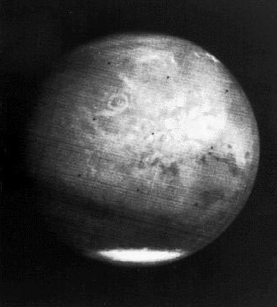
Mariner 7 far-encounter photograph of Mars. The circular feature Nix Olympica can be seen in the middle of the photograph. This photograph was acquired at a distance of approximately 475,000 km.
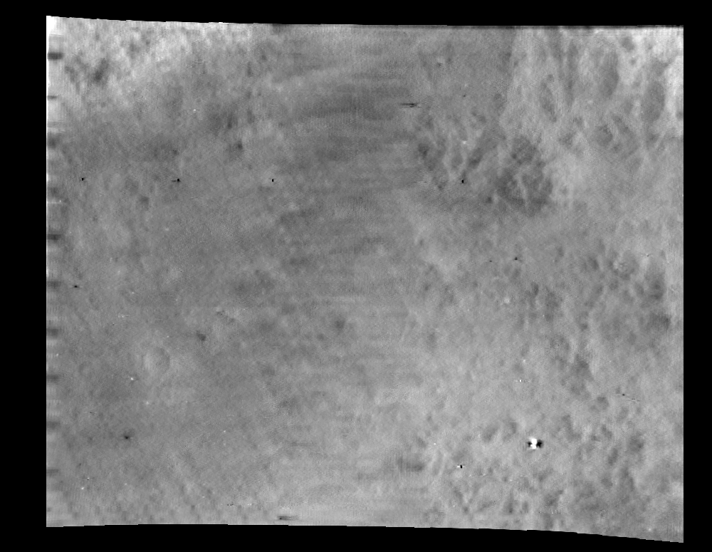
Mariner 6 photograph 6N6 centered at 10 degrees S, 323 degrees E. North is at 11:00. The photograph is 1,125 km by 2277 km. The photograph was acquired at a distance of 5,355 km.

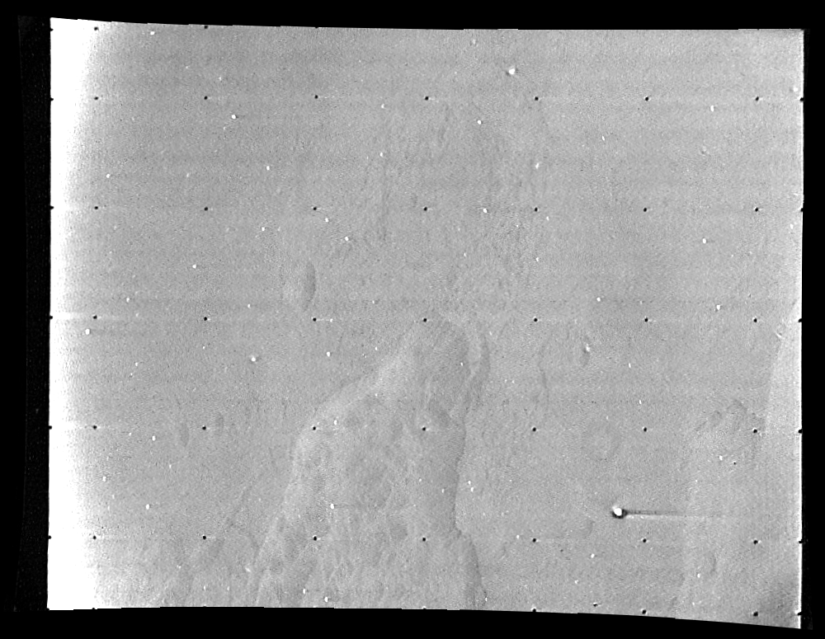

Mariner 6 photograph 6N14 centered at approximately 13 degrees S, 324 degrees E. North is at 11:30. The photograph is 99 km by 237 km. The photograph was acquired at a distance of 4,903 km.
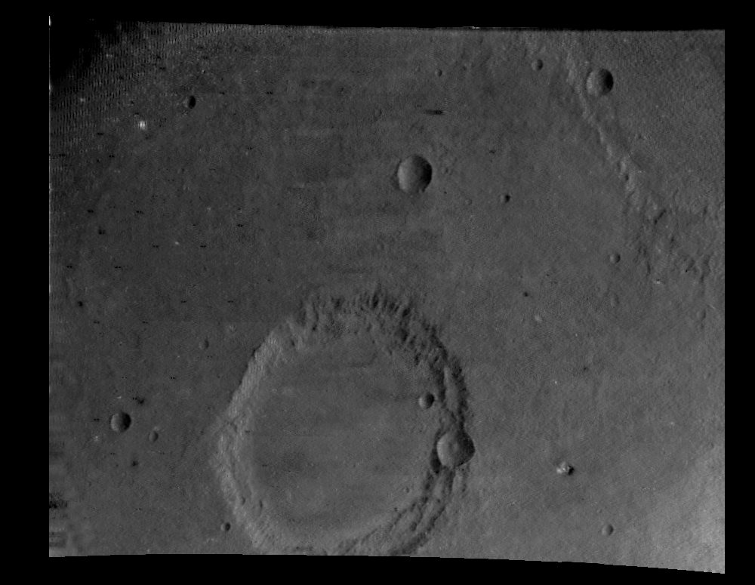

Mariner 6 photograph 6N18 centered at 16 degrees S, 356 degrees E. North is at 11:30. The photograph is 77 km by 103 km. The photograph was acquired at a distance of 3,746 km.
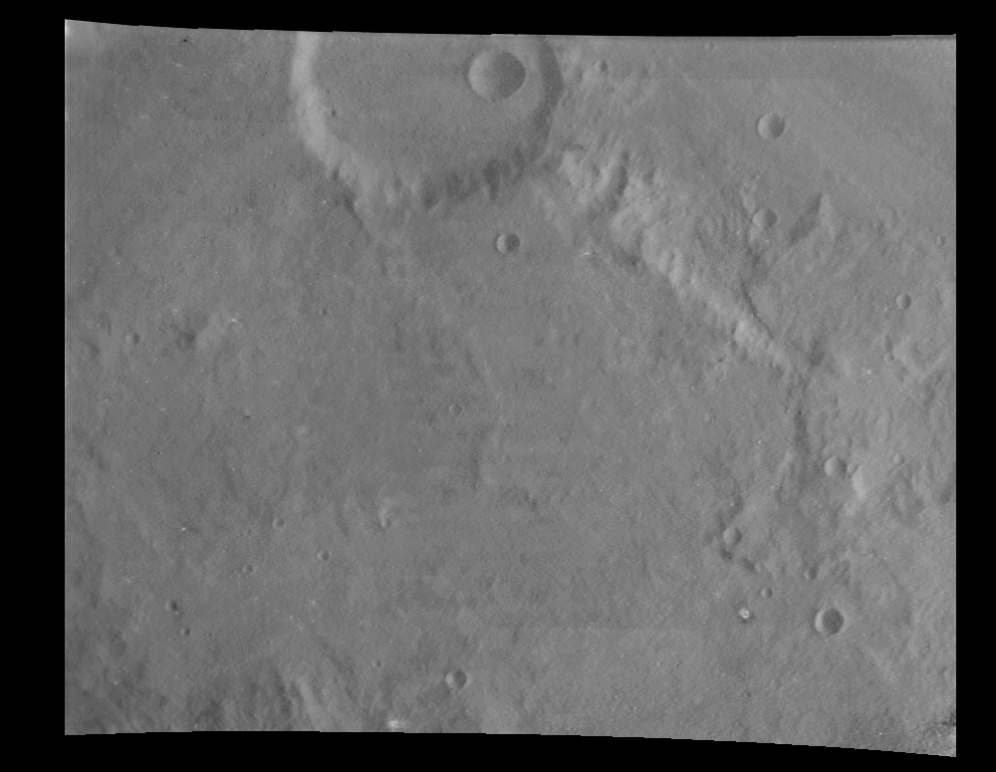

Mariner 6 photograph 6N22 centered at 15 degrees S, 20 degrees E. North is at 12:30. The photograph is 73 km by 84 km. The photograph was acquired at a distance of 3,498 km.
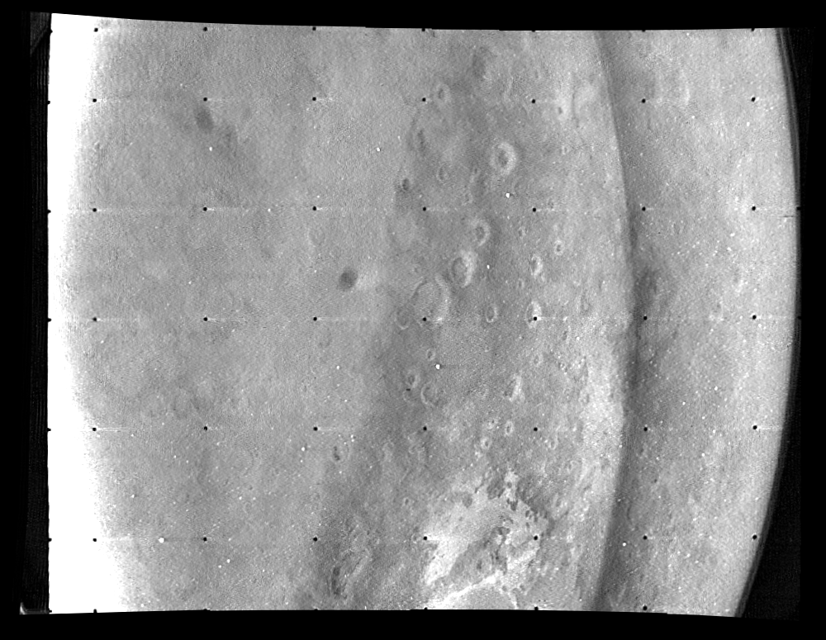

Mariner 7 photograph 7N7 centered at 12 degrees S, 4 degrees E. North is at 9:30. The photograph is 1,406 km by 3,143 km. The photograph was acquired at a distance of 7,136 km.
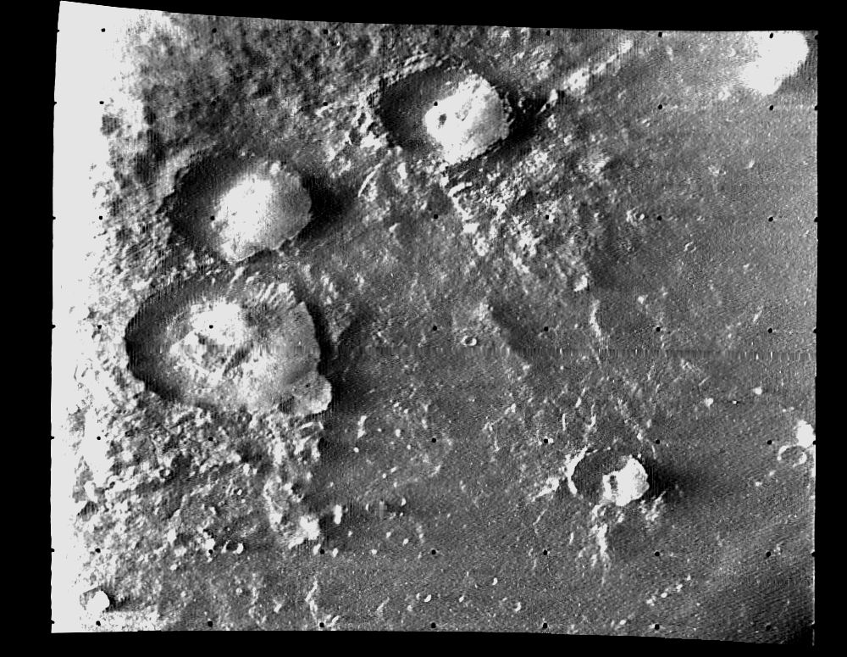

Mariner 7 photograph 7N12 centered at 61 degrees S, 339 degrees E. North is at 9:30. The photograph is 145 km by 161 km. The photograph was acquired at a distance of 6,095 km.

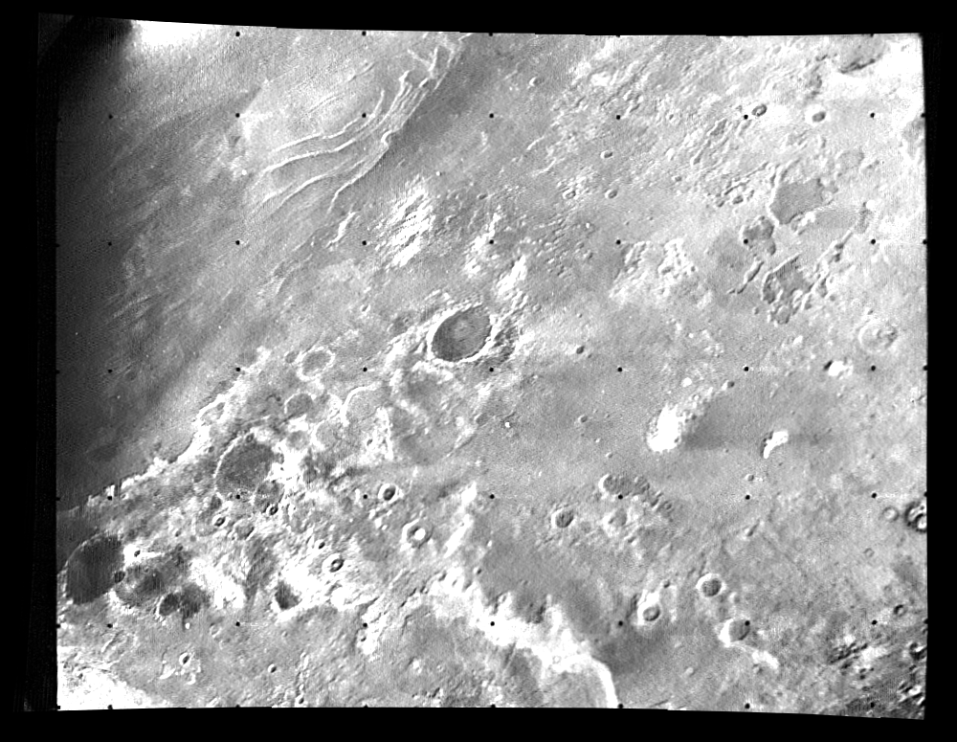
Mariner 7 photograph 7N17 centered at 76 degrees S, 26 degrees E. North is at 11:00. The photograph is 1,324 km by 1,546 km. The photograph was acquired at a distance of 5,355 km.

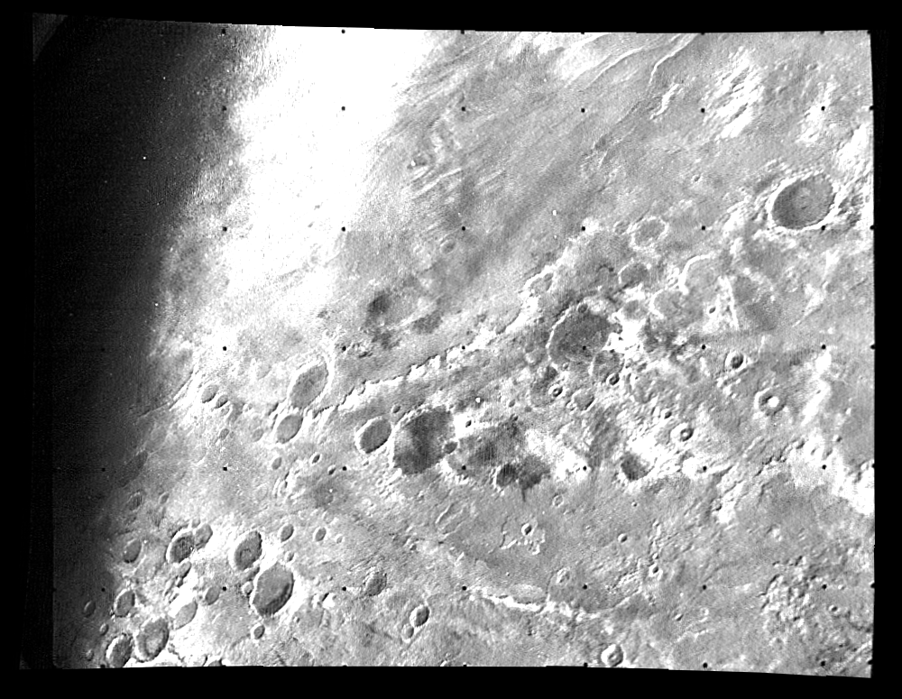

Mariner 7 photograph 7N19 centered at 78 degrees S, 69 degrees E. North is at 10:00. The photograph is 1,294 km by 1,821 km. The photograph was acquired at a distance of 5,013 km.



